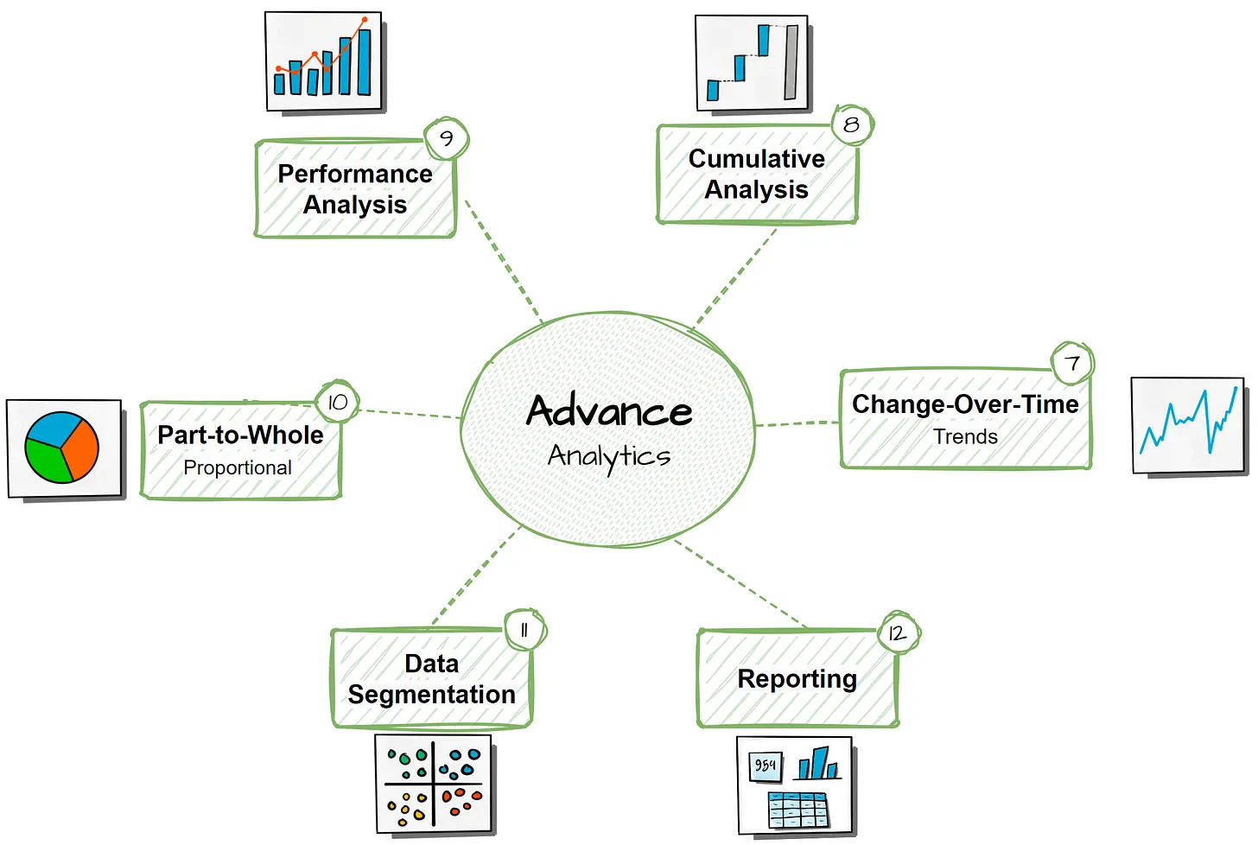 **SQL Customer performance Report Using SSMS**

* **Changes Over Time Analysis – Spot trends and track growth using DATEPART (), DATETRUNC (), and SUM ()**

**Analyze how a measure evolves over time.**

**Helps track trends and identify seasonality in your data.**

**For E.G. Total Sales by Year, Avg Cost by Month**   
  
**Analyze Sales Performance Over Time.  
  
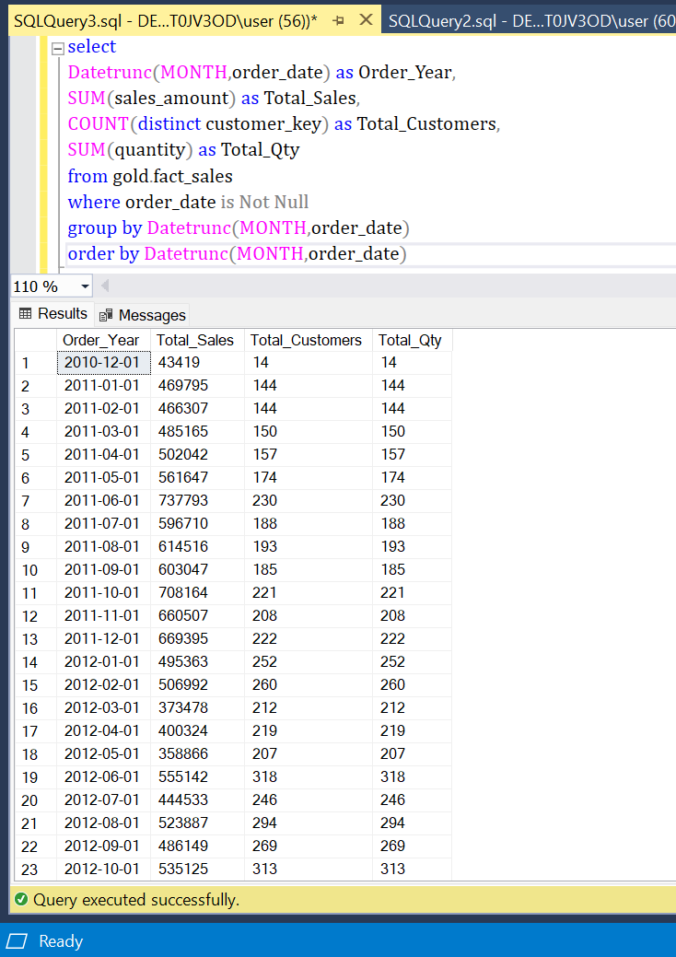**

* **Cumulative Analysis – Calculate running totals and moving averages with SUM () OVER () and AVG () OVER ().**

**Aggregate the data progressively over time.**

**Helps to understand whether our business is growing or declining.**

**For E.G. Running Total by Year, Moving Avg of Sales by Year  
  
Calculate the total sales per month and the running total of sales over time**

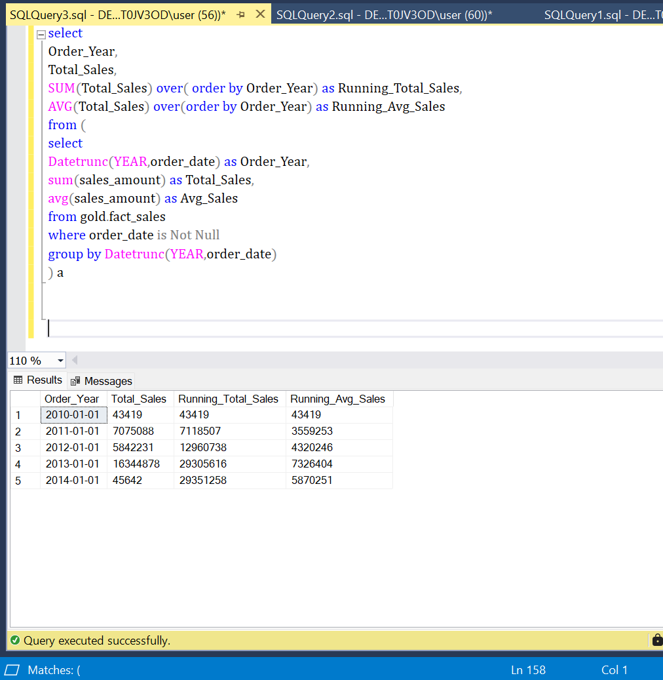

* **Performance Analysis – Use LAG (), AVG () OVER (), and CASE to measure trends and compare performance.**

**Comparing the current value to a target value.**

**Helps measure success and compare performance.**

**For E.G. Current Year Sales, Previous Year Sales  
  
Analyze the yearly performance of products by comparing their sales to both the average sales performance of the product and the previous year's sales**

* **Part-to-Whole Analysis – Compare different metrics using SUM (), AVG (), and SUM () OVER ().**

**Analyze how an individual part is performing compared to the overall,**

**allowing us to understand which category has the greatest impact on the business.**

**For E.G. (Sales / Total Sales) * 100 by Category, (QTY / Total QTY) * 100 by Category  
  
Which Category Contributes the most to overall sales**

* **Data Segmentation – Organize data into meaningful categories with CASE and GROUP BY.  
   Group the data based on a specific range.  
   Helps understand the correlation between two measures.  
   For E.g. Total Products by Sales Range  
    
  Segment products into cost ranges and count how many products fall into each segment.**

